COLLEGE OF ENGINERING AND COMPUTER STUDIES

**OUTCOMES EVALUATION 1**

**Input & Output**

Submitted By

Mike Luis Villegas

Course & Section

CS 1-1

Date

September 7, 2021

**OUTCOMES OUTLINE**

1. **DESCRIPTION**

**Learning the basics of coding by using Visual Studio code.**

1. **THEORETICAL FRAMEWORK**

|  |  |  |
| --- | --- | --- |
| INPUT | PROCESS | OUTPUT |
| 1. **Name** 2. **Gender** 3. **Age** 4. **Address** 5. **YnS** 6. **CNumber** | **getline(cin,Name);**  **getline(cin,Gender);**  **cin >> Age;**  **cin.ignore();**  **getline(cin,Address);**  **getline(cin,YnS);**  **getline(cin,CNumber);** | **Name**  **Gender**  **Age**  **Address**  **Year and Section**  **Contact No.** |

1. **SCREEN SHOTS**
2. **Visual Studio Code**

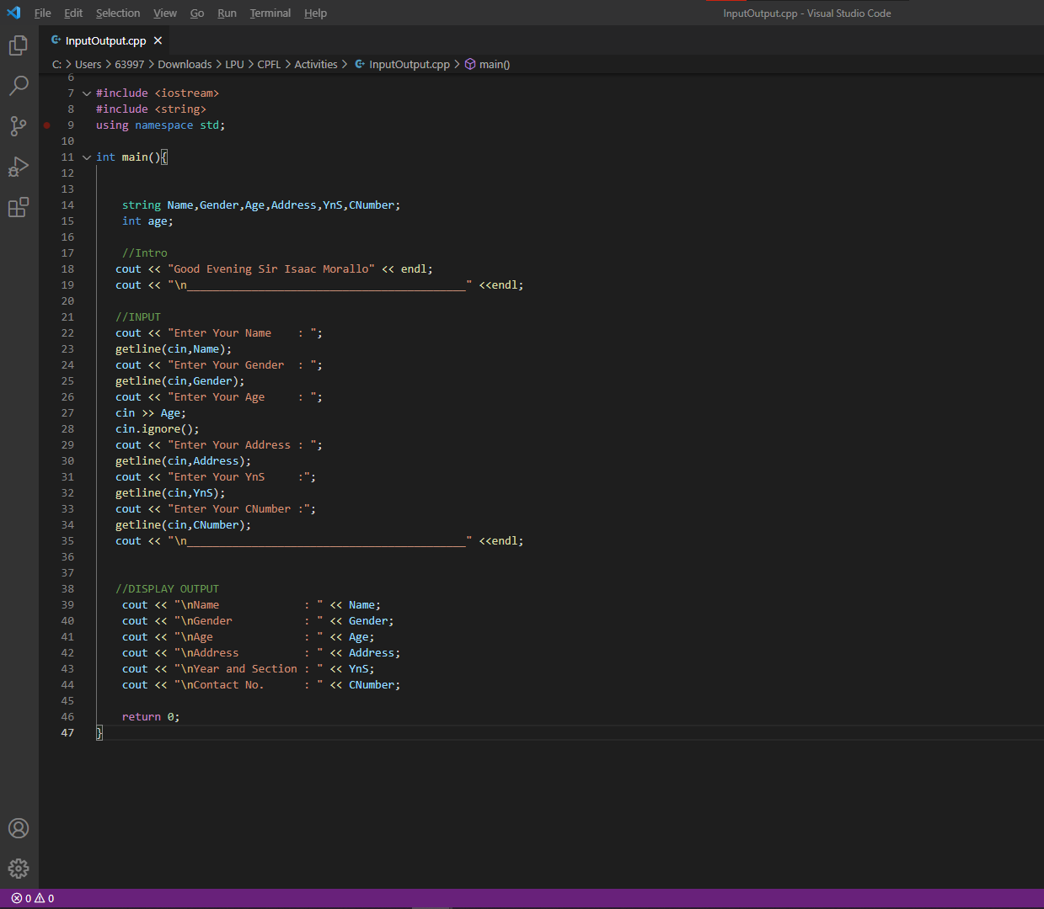

1. **Sample Input/Output**

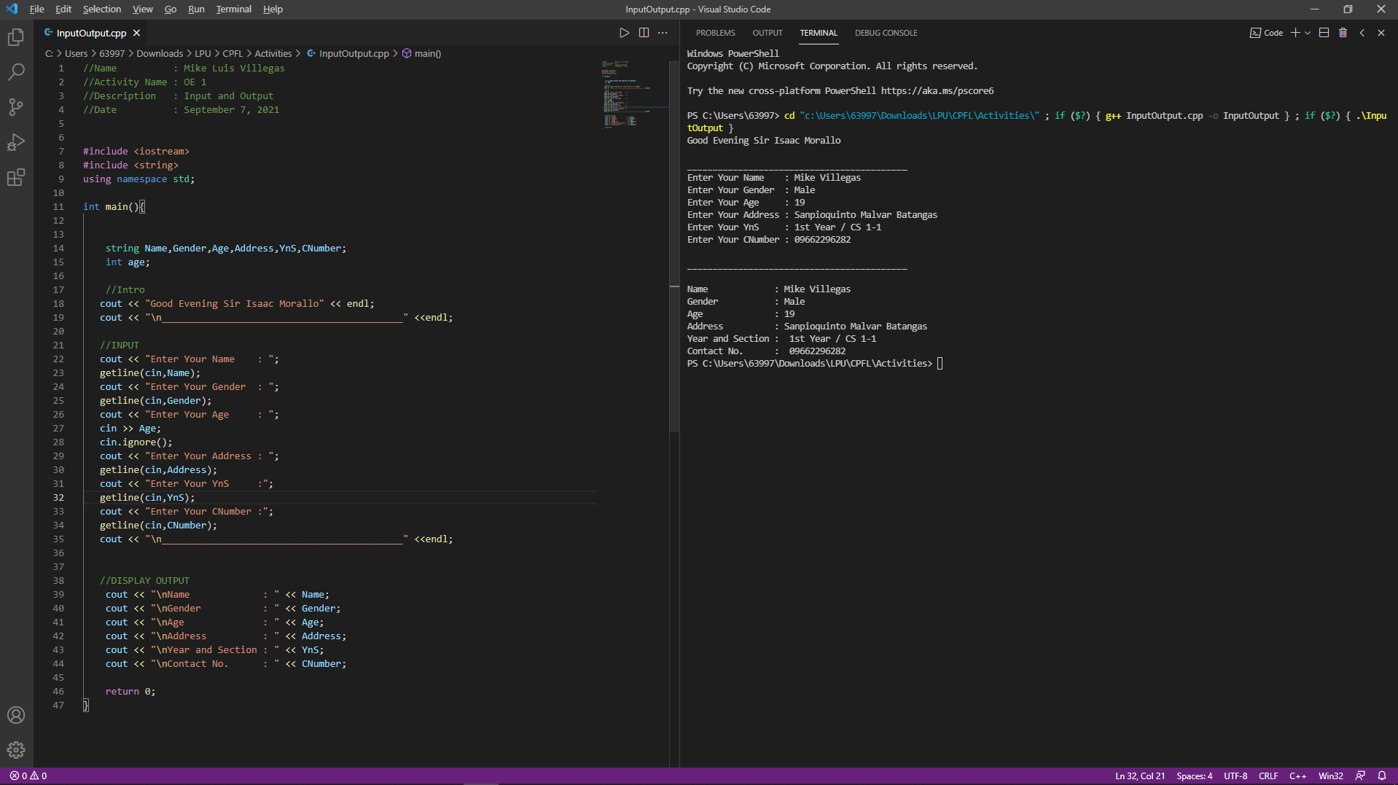

1. **PROGRAM SOURCE CODE**

//Name : Mike Luis Villegas

//Activity Name : OE 1

//Description : Input and Output

//Date : September 7, 2021

#include <iostream>

#include <string>

using namespace std;

int main(){

string Name,Gender,Age,Address,YnS,CNumber;

int age;

//Intro

cout << "Good Evening Sir Isaac Morallo" << endl;

cout << "\n___________________________________________" <<endl;

//INPUT

cout << "Enter Your Name : ";

getline(cin,Name);

cout << "Enter Your Gender : ";

getline(cin,Gender);

cout << "Enter Your Age : ";

cin >> Age;

cin.ignore();

cout << "Enter Your Address : ";

getline(cin,Address);

cout << "Enter Your YnS :";

getline(cin,YnS);

cout << "Enter Your CNumber :";

getline(cin,CNumber);

cout << "\n___________________________________________" <<endl;

//DISPLAY OUTPUT

cout << "\nName : " << Name;

cout << "\nGender : " << Gender;

cout << "\nAge : " << Age;

cout << "\nAddress : " << Address;

cout << "\nYear and Section : " << YnS;

cout << "\nContact No. : " << CNumber;

return 0;

}

1. **LEARNING OUTCOMES**

**I’ve learned that coding is tedious and step by step process. VERY case sensitive and excessive use of rarely used punctuation such as Colons, Semi-Colons, Quotation Mark, etc... Although for now I just copied and pasted some of the codes I am excited to learn more in depth and more advanced lessons about programming.**

1. **REFERENCES (If any…)**

<https://stackoverflow.com/questions/67823114/error-g-exe-no-such-file-or-directory-g-exe-fatal-error-no-input-files-i>

